Name: Saif-ur-Rehman
Registration No: 0407241-3045
Course: Database Systems
Assignment#1
- Title of Mini World

“LIBRARY MANAGEMENT SYSTEM FOR UNIVERSITY LIBRARY”

- Motivation Behind this Idea
In most institutions of learning, library records may be kept using manual records or outdated systems. This may result in issues like misplaced records, inaccurate calculation of fine amounts, problems in tracing issued books, and wastage of time.
The reason for designing a Library Management System is to establish a structured database for the effective management of books, students, and the issuing and return of books.
- Different User Role for the System
The System will have the following user roles
- Librarian
- Students
- Administration
- Data Requirements

The System Requires the following Data:
Books
- Book_ID
- Title
- Author
- Publisher
- Edition
- Category
- Quantity
- Available_Quantity

Students
- Student_ID
- Name
- Department
- Semester
- Phone
- Email
Issue_Record
- Issue_ID
- Student_ID
- Book_ID
- Issue_Date
- Due_Date
Return_Record
- Return_ID
- Issue_ID
- Return_Date
- Fine_Amount

- Transaction Requirements
Transaction | Initiated By | Frequency
Add New Book | Liberian | Occasionally
Update Book Details | Liberian | Rare
Issue Book | Liberian | Daily
Return Book | Liberian | Daily
Search Book | Student | Frequently
Generate Reports | Administrator | Monthly

- Mission Statement
The Library Management System has the following mission: “To provide a reliable, secure, and efficient database solution for the management of library operations and the accurate tracking of books and student transactions.”

- System Definition
The Library Management System is a computerized database management system that aims to store, manage, and retrieve data about books, students, book issuance, and return transaction data in an efficient way, maintaining data integrity, avoiding data redundancy, and supporting multiple users with different roles.
- Mission Objectives
- To maintain accurate records of the books and students.
- To automate the book issue and returning Process.
- To Track due dates and calculating the fines automatically.
- To minimise data redundancy and ensure data consistency.
- To generate useful reports for management.
- Major User views for the Proposed Database System
- Liberian View
- Student View
- Administrator View

- Cross Reference of user views with Main type of Data

User Role | Books | Students | Issue_Record | Return_Record
Liberian | ✓ | ✓ | ✓ | ✓
Students | ✓(View only) | ✓(Own Data Only) | ✓(Own Record) | ✓(Own Record)
Administrator | ✓ | ✓ | ✓ | ✓

- Complete Conceptual EERD for Library Management System
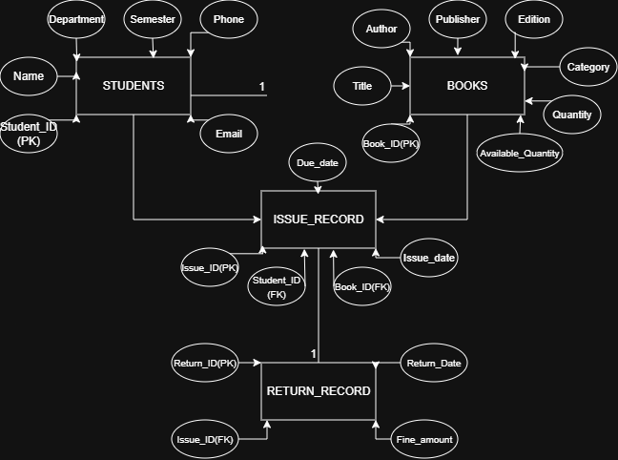

Table Name | Attributed | Primary Key | Foreign key
Students | Student_ID, Name, Department, Semester, Phone, Email | Student_ID, | None
Books | Book_ID, Title, Author, Publisher, Edition, Category, Quantity, Available_Qty | Book_ID | None
Issue_records | Issue_ID, Student_ID, Book_ID, Issue_Date, Due_Date | Issue_ID | Student_ID, Book_ID
Return_records | Return_ID, Issue_ID, Return_Date, Fine_Amount | Return_ID | Issue_ID
- Complete Logical Database Design (Tabular Form)

- Physical Database Design (MS SQL Server)

